Angular

Package.json

Dependencies on the angular Project are found here

Angular.json

Project specific configurations like root project

Tsconfig.json

Typescript configurations details

Src/index

main index file, file to render in the browser

src/styles.cc

global styles

src/app

components, services, htmls

app.config.ts

configure angular models

app.routes.ts

define angular routes

angular cli

command line interface tool to initialize, develop and maintain angular apps from command shell

component standalone property

angular components marked as standalone do not need to be declared in an ngmodule, this components manage their own template dependencies (components, directives, pipes) via the imports property

export class (Component) in order to be available for main.ts

Interpolation

Title:string = “this is loaded dynamically”

<h1>{{title}}</h1>

Any value in the {{}} is converted into a string

Property binding

imgUrl =”http image”

<img [src]=”imgUrl”>



Event binding

<button (click)=”updateCounter()”>Click</button>

<button (mouseover)=”updateCounter()”>Click</button>

</input type=”text” (keyup)=”keyEntered($event)”>

keyEntered(event:any){console.log(event.keycode)}

OR

</input type=”text” (keyup.enter)=”keyEntered()”>

Template variable

Keep data into a template variable, keep not only the value but also all properties from the element

</input type=”text” (keyup.enter)=”keyEntered(user)” #user>

keyEntered(user:HtmlInputElement){console.log(user.value))

two way data binding with ngModel

<input type=”text” [(ngModel)]=”username”>

username:string =’john Doe’

<h3>{{username}}</h3>

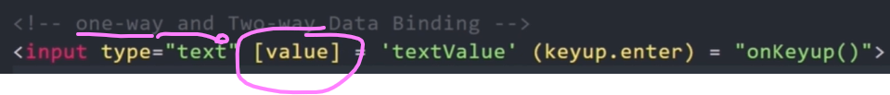

Directives

Allow to manipulate the dom and add additional behavior to elements

Types

Components directive, directive with template

Structural directives, alter layout of dom (ngIf, ngFor, ngSwitch older, @if, @for @switch new)

Attribute Directives, change appearance or behavier of an element (ngClass, ngStyle)

Custom directive

Old

<h2 *ngIf=”isLoggedIn; else message”>{{username}}</h2>

<ng-template #message>

<h2>user not logged in</h2>

</ng-template>

new

@if (isLoggedIn){

<h2>{{username}}</h2>

}

@else {

<h2>user not logged in</h2>

}

Ng-template

Allow to define content that can be used later in the app, it is not render in the dom unless we call it

Ng-template-outlet

Similar to ng-template, to use as a directive instead of else

<ng-template #callToAction>

<button>Join</button>

</ng-template>

<div [ngTemplateOutlet]=”callToAction”>

<h5>Sidebar<h/>

***it will add ng-template callToAction here***

</div>

Access array index

<h4>{{users[3]}}</h4>

ngFor (old)

<h3 *ngFor=”let user of users”>{{user}}</h3>

@for(new)

@for(user of users; track user){

<h3>{{user}}</h3>

}

@for with arrays

usersObj: Array<any>=[

{

Id: 1, name: ‘John’, email:’john@gmail.com’

}]

@for(user: usersObj; track user){

<li>{{user.id}} {{user.name}} {{user.email}}</li>

}

Add object to array

Array.push(newObj);

Array get index from obj

Index: number = Array.indexOf(user);

Array remove obj using index

Array.splice(index, 1) //from index delete 1 element

For index and count

(old) <li *ngFor=”let user of users; let i=index; let counter= count” (click)=”deleteUser(i)”>Delete</li>

@for(user of users; track user; let i =$index; let counter = $count){

<li (click)=deleteUser(i)>Delete</li>

}

@empty

If evaluates empty is true it renders its content, , if empty it will just render it once

@for(user of users; track user; let i =$index; let counter = $count){

<li (click)=deleteUser(i)>Delete</li>

}

@empty{

<p>nothing to display</p>

}

@for other functionalities available at for block

$First

$last

$even

$odd

@for(user of users; let initial = $first; let last= $last; let odd = $odd; let even=$even)

Ng switch

(old)

<div [ngSwitch]=”usersRole”>

<p *ngSwitchCase=”’Admin’”>Welcome Admin</p>

<p *ngSwitchCase=”’Member’”>Welcome Member</p>

<p *ngSwitchDefault>Login</p>

</div>

@switch(usersRole){

@case(‘admin’){

<p>Welcome Amin</p>

}

@case(‘member’){

<p>Welcome Member</p>

}

@default{

<p>Login</p>

}

}

ngStyle

modify the style of an element base on a condition

ngClass

add a class based on a condition

Structural Directive

Add or remove dom elements, leading * symbol (old way)

Attribute directive

Change appearance or behabior of a dom element

ngStyle

ngClass

parent component is the outer component, parent component can pass data to the child component, child can also pass data to the parent component

child component is the inner component

parent

appPostTitle: string = ‘Post 1’

child receives postTitle

<app-child-component [postTitle]=”appPostTitle”>¨

@Input() postTitle: string = ‘’; //input to tell this is coming from its parent component

Get data into the parent component from the child component

@ViewChild

Child

childMessage: string = ‘hello from child component’

Parent

@ViewChild(ChildComponent) childMessage: any;

(If you try to get the value in the parents constructor it will be undefined since it is not available yet also if you try to use it in string interpolation (child not completely initialized), AfterViewInit phase will have it ready)

AfterViewInit (runs after component and its children are fully initialized)

Export class AppParentComponent implements AfterViewInit{

ngAfterViewInit(){

console.log(this.childMessage);

}

You can assign inside ngAfterViewInit() a variable so it can be used in string interpolation

@Output

For actions like button clicks or user interactions, to pass it from the child component to the parent component

Child

parentMessage:string =”message from child using click event”;

@Output() MessageEvent = new EventEmitter();

sendMessage(){ this.MessageEvent.emit(this.parentMessage); }

<button (click)=”sendMessage()”>Send Message To Parent</button>

Parent

<app-child-component (MessageEvent)=”receiveMessage($event)”>

<p>{{messageFromChild}}</p>

receiveMessage(message: string) {

console.log(message)

this.messageFromChild = message;

}

messageFromChild:string = ‘’;

@ViewChild has to look on all component for the looking value, if it is large then better to use @Output which will only report when needed

Ng-content content projection

@Input send Data to child component

Ng-content send Html blocks to child component

Parent

<app-card>

<p>This is loaded using ng-content</p>

<app-card>

Child

<ng-content>html from parent goes here</ng-content>

Multiple

In parent

In app-card

Lifecycle hooks

Special methods provided by angular that allow us to tap into different stages of a component’s lifecycle. Angular provides hooks that let us run custom logic at specific times.

Constructor(not part of hook lifecycle)

Called before ngOnInit, first method called, view is not ready yet

ngOnInit

called only once when the component is initialized

ngOnChanges

called every time an input **property changes**

ngDoCheck

called during every change detection run, even if nothing changes

ngAfterContentInit

called once after the component’s content has been initialized

after ng-content (content sent from parent) is rendered, to work with that conten after it has been projected

ngAfterContentChecked

called after every check of the component’s content, like ngDoCheck but for projected content of ng-content

ngAfterViewInit

called only once after the component’s view (DOM) has been initialized

ngAfterViewChecked

called after every check of the component’s view, triggered after every time the view changes

ngOnDestroy

called just before the component is destroyed

Load component inside div programatically with ngComponentOutlet

<div *ngComponentOutlet=”loadComponent()”></div>

Load component when button is clicked with ViewContainerRef



Remove component from ViewContainerRef



Pipes

A way to transform data directly in the template

Built in pipes, angular pipes out of the box

Custom pipes, let you define your own transformation

Data -> Pipe transform -> Formatted data

Cleaner, so the component does not have that code and it can be reused in different places

Ex: built in uppercase pipe and number pipe









Json pipe to display complex object

{{ user }} -> display [object Object]

{{ user | json }} -> {“name”:”Fer”, “age”:39}

->

Multiple pipes



Services

By dependency injection one single instance is used instead of using a new instance each new is used

Injector

Area where all instance services are stored

Optional fields with ?, not mandatory

Template Driven Form

Reactive Forms (setup and validation in components)

Form group ex:

Nested Form Group Ex:

Reactive Form Array inside a FormGroup

Reactive Form Builder

Custom Validator

Routing

Router link

Directive to go to a route



Router-outlet

A <router-outlet> in Angular is a placeholder directive that tells the router where to dynamically load and display different components (views) based on the current URL

Href vs router link

Href reloads the page, router link doesn’t reload the page just loads the component at the router-outler tag

Routerlinkactive

Adds a css class when the route is active

Route With parameter

ActivatedRoute to receive parameter from view router link

Observable

Subscribe() calls the observable as If it was a function

Next() allows to return a value from observable

Any change on the observable and the subscribe method will trigger

Keeping subscribe will spend resources of memory, you can unsubscribe to stop listening

Multiple router parameter



Query parameters



Angular Routing File

Navigate to a route programmatically from a component



With parameters and query parameters



Wildcard

Rxjs

Angular Testing

Jasmine

In jasmine tests are known as specifications or specs which are grouped in test suites.

Pending() test not ready to be executed

Ng test, compiles and runs our tests specifications by the karma test runner used by angular internally, lanch a browser to test with specs ran and more information

Basic ex:

Jasmine spies

Keeps track of an object to share information of for example times a method was called

In general when creating specs we just want to create an instance of the validated class, for example a service, and all dependencies required by this instance should be mocked instead of real instances, that way we make sure if the spec fails is because of changes in the actual asserted class

BeforeEach

Called before each of the specs:

beforeEach(() => {

loggerSpy = jasmine.createSpyObj(‘LoggerService’, [‘log’]);

calculator = new CalculatorService(loggerSpy);

});

Inject a service

Using TestBed allows to get providers, imports using dependency injection

Describe(‘CalculatorService’, ()=>{

Let calculatorService:CalculatorService,

loggerSpy:any;

beforeEach(() => {

loggerSpy = jasmine.createSpyObj(‘LoggerService’, [‘log’];

TestBed.configureTestingModule({

Providers: [

CalculatorService,

{provide: LoggerService, useValue: loggerSpy}

]

});

calculatorService = TestBed.inject(CalculatorService);

})

});

Disable all specs by adding x to the describe:

Xdescribe(‘CalculatorService’, () => { …

Disable test by adding x before it

Xit(‘should add 2 numbers’, () =>{…

Only execute current specs by adding fdescribe, will only execute this specs on ng test

Fdescribe(‘CalculatorService’, () => {…

Only execute 1 spec in the test suite

Fit(‘should sum 2 numbers’, () => {…

Testing Http Services

While using the mock HttpClientTestingModule, when the call to the service is done it is not returning the subscribe method results, until the request flush method is called which adds the data to be returned by the request and used in the subscribe method

beforeEach(() => {

TestBed.configureTestingModule(() =>{

Imports:[HttpClientTestingModule], //simulate http calls

Providers: [CoursesService]

});

coursesService = TestBed.inject(CoursesService);

httptestingController = TestBed.inject(HttpTestingController)

});

It(‘should retrieve all courses’, ()=> {

cousesService.findAllCourses().subscribe(courses => {

expect(courses).toBeTruthy(‘no courses returnd’);

expect(courses.length).toBe(12,’Incorrect number of courses’);

});

Const req = httpTestingController.expectOne(‘api/courses’)

Expect(req.request.method).toEqual(‘GET’);

Req.flush({payload: Object.values(COURSES)}); //request is going to return this object to the subscribe method as a simulated response, subscribe method will not trigger until calling the flush method

}

Assert no other http methods were called unintencionally

httpTestingController.verify() (at the end of the test, could use afterEach for this) //this will assert only those explicitely called with expectOne were called, If any other not specified was called this will fail

ex:

configure Test bed

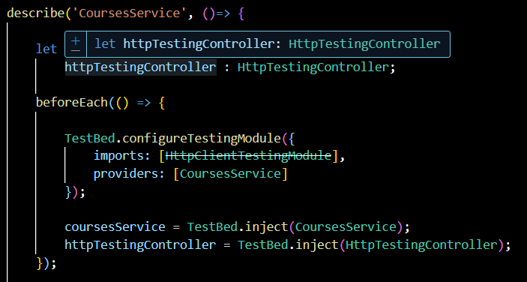

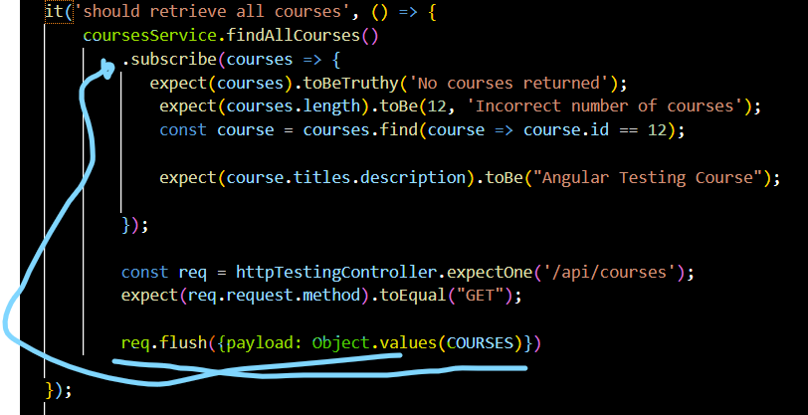

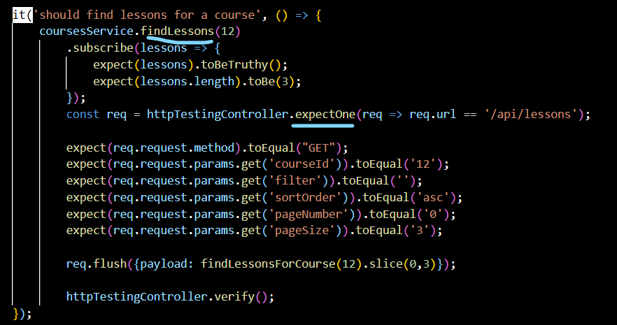

Component View Testing

let el: DebugElement

el = fixture.debugElement;    //gives access to the DOM elements of the component

if changes on the view had happen we need to make sure it is reflected on the view

fixture.detectChanges();  //triggers change detection cycle so that the view is updated with the data

print current dom

console.log(el.nativeElement.outerHTML); //prints the HTML of the component to the console for debugging

get elements in the view by css class

const cards = el.queryAll(By.css(".course-card"));

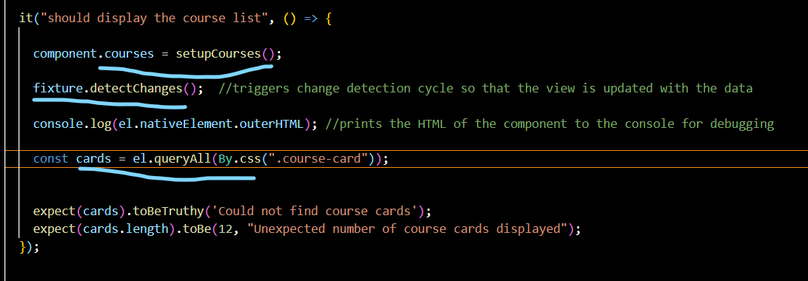

Get first element of dom by class

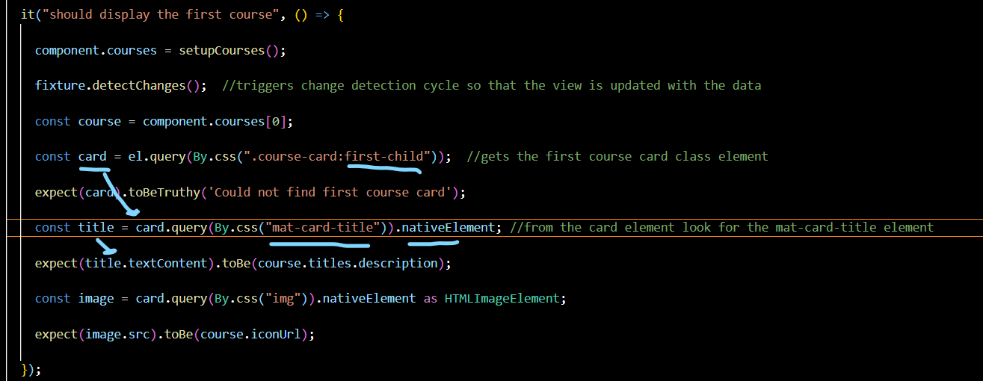

Container Component

The container component acts as the data orchestrator, fetching information from the backend via services and managing the application state. It then passes this data down to its child presentation components.

Presentation Component

The presentation components, in turn, simply render the UI based on the data received via @Input and emit events via @Output for any user interactions, which the container handles.

Async test example, not ideal way (by using set timeout)

